Local image without any styles:
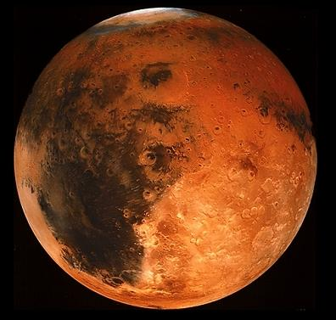

Local image with styles:
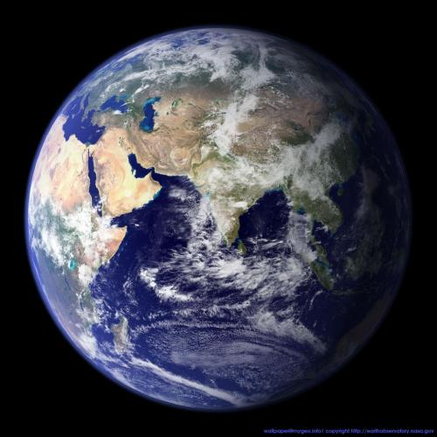

Remote image from: http://php.net/images/logos/php-med-trans-light.gif


Wrapping style inline
Hello World! Hello World! Hello World! Hello World! Hello World! Hello World! Hello World! Hello World! Hello World! Hello World! Hello World! Hello World! Hello World! Hello World! Hello World!

Wrapping style behind
Hello World! Hello World! Hello World! Hello World! Hello World! Hello World! Hello World! Hello World! Hello World! Hello World! Hello World! Hello World! Hello World! Hello World! Hello World!

Wrapping style infront
Hello World! Hello World! Hello World! Hello World! Hello World! Hello World! Hello World! Hello World! Hello World! Hello World! Hello World! Hello World! Hello World! Hello World! Hello World!

Wrapping style square
Hello World! Hello World! Hello World! Hello World! Hello World! Hello World! Hello World! Hello World! Hello World! Hello World! Hello World! Hello World! Hello World! Hello World! Hello World!

Wrapping style tight
Hello World! Hello World! Hello World! Hello World! Hello World! Hello World! Hello World! Hello World! Hello World! Hello World! Hello World! Hello World! Hello World! Hello World! Hello World!

Absolute positioning: see top right corner of page

Relative positioning: Horizontal position center relative to column,
Vertical position top relative to line

